In this section we wll focus on how to control the ball movements
Now Teacher did not like the size of the ball So the teacher go to scale and then scale it to 0.8 from 1 in all axis
Now focus on the ball IOA
Move the ball like it is attached to the floor below it.
So now add the new script associated with the ball IOA and then to add component>New script button> Type the name of the script(We named it BallController) and then press the button create and add Script
Now open the script file in Visual Studio
________________________________________________________________________________
Note:-
when you create a file in above way then it is formed in ssets folder Drag and drop it in the scipt folder sothat our project is organised
________________________________________________________________________________
Fun Fact:-
Before Visual Studio Monodevelop-Unity editor was used to edit the script
________________________________________________________________________________

Now drag and drop this script in script folder so that we can be organised
________________________________________________________________________________
Note:-
whenever you edit a file in an editor and you move it from its location or deleted it
then it may get removed from the Editor.
________________________________________________________________________________

No save scene in newer version of unity.
Now we want to move our ball in zig zag direction
so we want to move it in either z axis or x axis
Now we will change our camera angle and see it from backward side so that our x and z axis looks in front like below
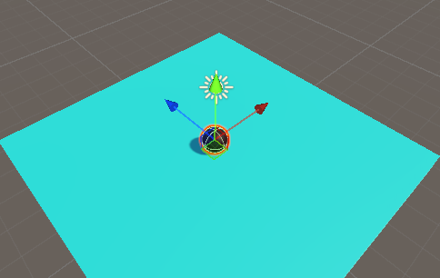
Now we will move our ball in a away shown in below screenshots
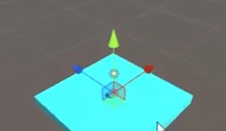
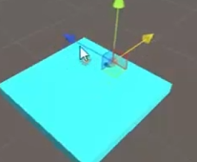
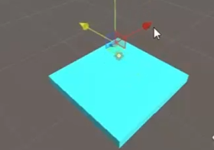
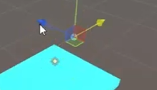

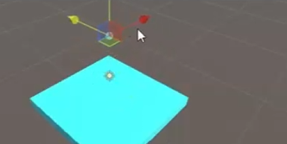

So every time we press mouse button or touch on the screen then
we are going to change the direction from x to z and then z to x
So tht wwe aare going to do in our script
Now we make a variable in our BallController Script called speed of float type and private acces modifier
Through this we will decide by what speed our ball will move
Now since the speed is private variable it will not be shown in the Unity Editor
but we want it to be shown
So we will do so by a concept
I think this concept is similaar to keyword or shortcode which we enclosed between square brackets
and place where we want to apply it So
To make the our private variable to be shown in the Unity editor we need a
Serializable is called keyword
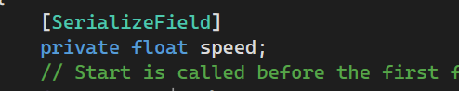
Now you can see the parameter even though it is private you can still see them in the editor as shown below
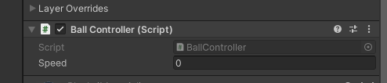
Now you can see that the rigidbody is attached to the ball it means that so that it can interact and get facilitiues of the Unity's physics engine so that we can give the ball velocity in x , y and z direction
We will access the Rigidbody component attaached to the ball and using this rigidbody component we can give velocity to the component in x and z direction
Now we wil declare a variable Rigidbody rb that will contain the reference to the RigidBody of the ball
Now we will declare a function called awake inside the script related to ball which is will be automatically before start
We can use this Awake function to get access to the rigid body of the ball
by using get component as shown above

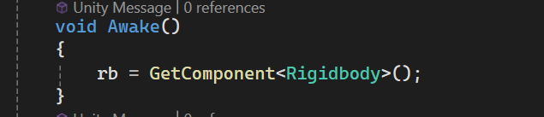
So by above rb get the reference of the rigidbody attached to the ball
Now b using rb we can change any proprty of the rigidbody
Now in start function give velocity to the ball
by using Vector 3 object and in its constructor we give three values each representing x,y and z direction respectively and whatever value give here it will represent magnitude of the speed(maybe) in that particular direction
so we will give value of speed variable in first parameter and the 0 in both second or third parameter of the Vector3 constructor and then give the reference of that object to the rb.velocity as shown below
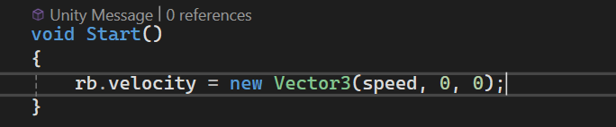
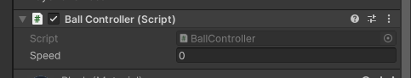
Now we will tune the value of speed parameter in the script subpanel as shown above
suppose we give a value of 2 Now we will see when we run our game then the ball will start moving in x direction
If we increase the speed then it will move with more speed.
Now what we need to do is that
Now we want that whenever we click on the screen then the x velocity will be zero and the z velocity will be equal tot he previous value of x we set through the editor and again if we click on the screen then this time z becoms and 0 and x speed becomes equal to value we set to speed paarameter of the ball
So for that we make a function named as Switch\Direction as shown below
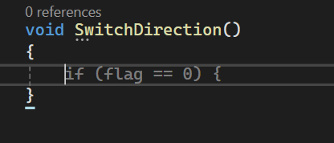
Make your function name ,variable and evrything such that if you see teh code later then you can see what it is actually doing
So now inside this function we check whether the ball has speed in z dierection by checking if its magnitude is greater than zero
and i\f yesthen we change the ball velocity such that this time Vector 3 object constructor has the same parameter configuration as it was previously
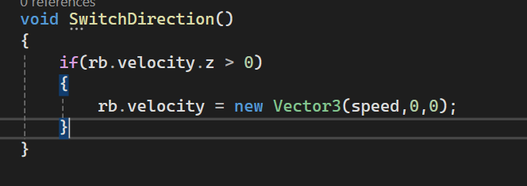
and then we add else if code to check that if the velocity of the ball in x direction is greater than 0 then we again reinitialise the velocity to the Vector 3 object and in the constructor the parameter configuration is such that first and second parameter is zero and the third parameter is speed

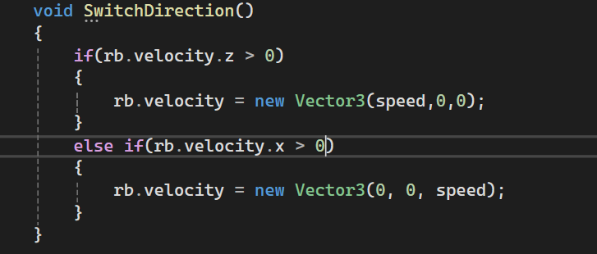
Now we will call this function inside the update method and this method will be called after every frame and whenever a click is happened on the screen or touch has happened in the screen then the block of the method will run we can do so by Input class as studied previously. Code is given below

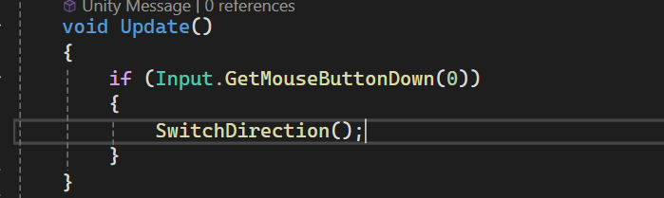
So now whenever a touch or click is on the screen then the direction of ball is changed from x to z direction

